
Kind Attention –
FALCON’s Response to RFQ
Weight base rejection system 2.5K
Option-2
December 21, 2023
Mr. Sandesh Mulik
M/s Flipkart

Offer Ref: F23-00535_OP2; Date: 21-12-2023

Subject – Techno -Commercial Offer of Weight base rejection system 2.5K PPH

Dear Team,

We are pleased to submit our Techno-commercial Offer in response to your RFP
As you will note, we have studied your requirements in great depth and, along with the information collected during the workshops and calls with you, we have put together a detailed technical proposal laid out in various sections and sequenced to enable you to understand our proposed solution and to re-enforce our commitment to be your partner in this strategic initiative.
In subsequent sections, we have highlighted the capabilities and experiences of Falcon Autotech with sections on our Automation Technologies.
To conclude, I would like to add my personal commitment, on behalf of Falcon Autotech. As we move through the RFP process, please do not hesitate to contact me and my team. We will be pleased to assist you for any further information or clarifications that you might have.

Best Regards,
Sandeep Bansal
Chief Business Officer

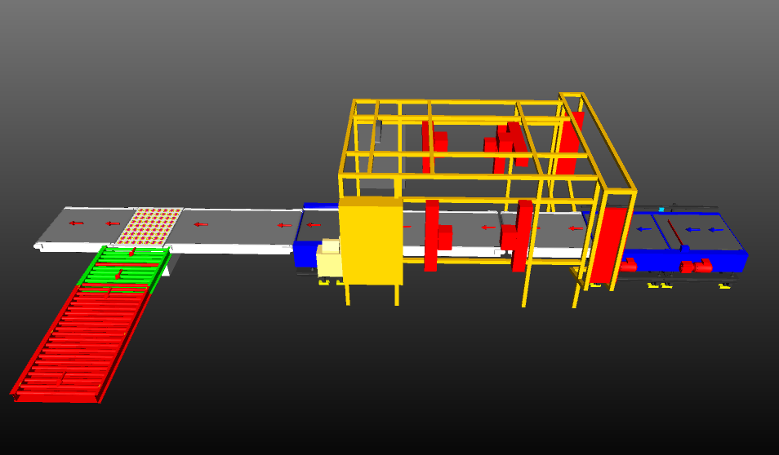

Proposal Reference – F23-00535-OP2

Response to RFP for Weight base rejection system 2.5K PPH Throughput
(Malur)

Falcon Autotech Private Limited
Plot No. 87, Sector Ecotech-1, Extention-1, Greater Noida, Uttar Pradesh 201308.

Contact – Sanyog Pratap Singh
Asst. Manager
Mob - +91 8750052591
Sanyog.singh@falconautoonine.com

Table of Contents
1. Glossary 6
2. Company Profile 7
3. Falcon’s Experience and Achievements in Sortation Space Globally 11
4. Reference Projects 13
4.1 Project 1- (CEP Client, India) 13
4.2 Project 2- (Client – E-Commerce, India) 14
4.3 Project 3- (Ecommerce Client, India) 15
4.4 Project 4- (CEP Client, UK) 16
4.5 Project 5- (CEP Client, Sydney) 17
5. About Falcon 18
6. Weight base rejection system 25
7. Handled Parcel Spectrumions Minimum Maximum 25
7.1 Parcel size Conveyable on the entire system. 25
7.2 Parcels to be loaded on Conveyor/Sorter shall have the following characteristics: 26
7.3 Parcel not loadable on the system 26
7.4 Types of Parcels 27
8. Proposed System Description 27
8.1 Objective 27
8.2 Process Flow 27
8.3 Main benefits of the proposed solution 28
9. System Components 28
9.1 Spacer 28
9.2 Auto Barcode Scanning System (Top Side) 29
9.3 Weighing Conveyor 30
9.4 Swivel Wheel Sorting Unit – Falcon 31
9.5 PVC Belt Conveyor 32
9.6 Powered Roller Conveyor 33
9.7 Idler Roller Conveyor 34
10. Proposed System Technical Details/BOM 35
10.1 Mechanical equipment 35
10.2 Electrical Equipment 35
10.3 Control System 35
11. Program Organisation 36
11.1 Delivery Schedule 36
12. Commercial Terms 36
12.1 Price Sheet 36
12.2 Payment Terms 36
13. Warranty Period 37
14. Exclusions 38

Glossary
S. No. | Term | Description
1 | RFP | Request For Proposal
2 | PPH | Parcels Per Hour
3 | IT | Information Technology
4 | BOQ | Bill Of Quantity
5 | I/O | Input/ Output
6 | PDP | Power Distribution Panel
7 | PC | Personal Computer
8 | UPS | Uninterrupted Power Supply

Company Profile
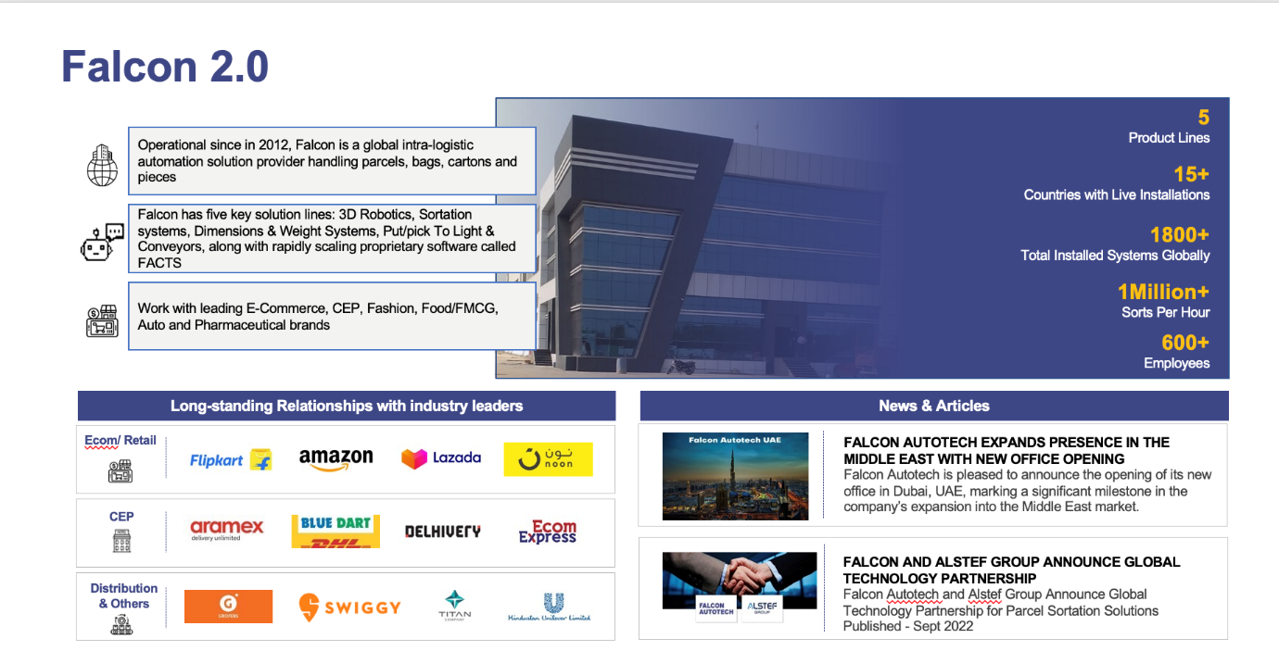
Falcon Autotech (Falcon) is a global intralogistics automation solutions company. With over 10 years of experience, Falcon has worked with some of the most innovative brands in E-Commerce, CEP, Fashion, Food/FMCG, Auto and Pharmaceutical Industries. With our proprietary software and robust hardware integration capabilities, Falcon designs, manufactures, supplies, implements, and maintains world-class warehouse automation systems globally. Falcon’s strong research and development team and the continuous focus on innovation reflect our strong solution line around Sortation, Robotics, Conveying, Vision Systems and IOT. Falcon has done over 1,800 installations across 15 countries on four continents.
Falcon Autotech is currently among the top 15 intralogistics automation company, our vision is to become top 10 intralogistics automation company in our focused product lines.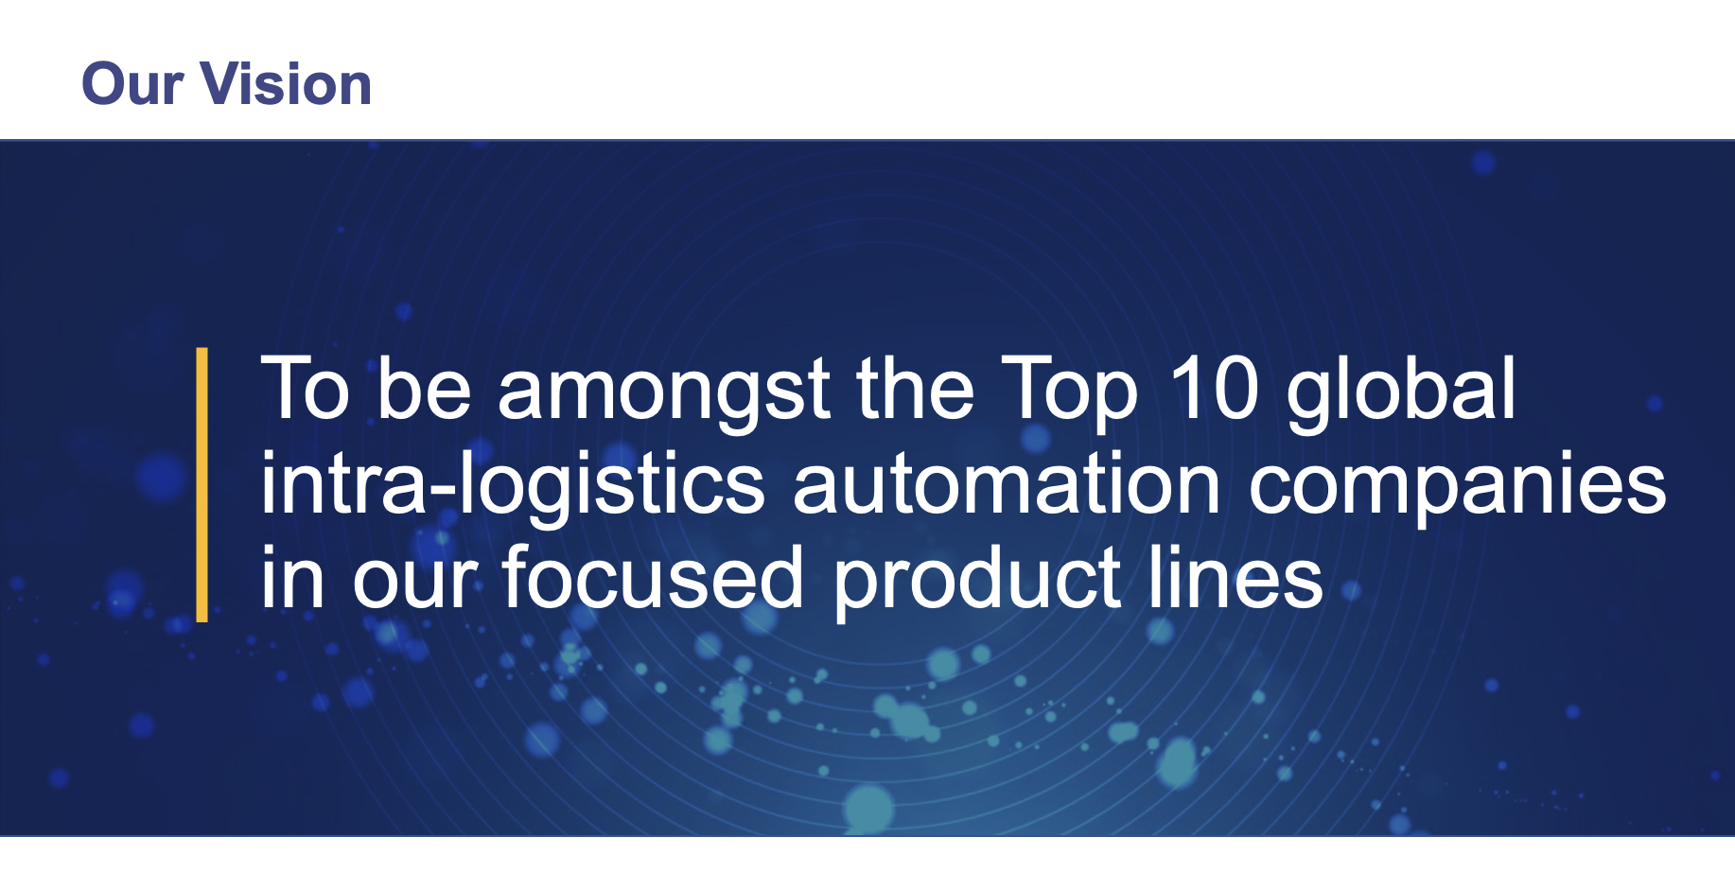
The team started out in 2004 solving special purpose automation problems for clients and later established Falcon Autotech in 2012 with strong focus on building standard technology stack spanning across Hardware, Firmware and Software to tackle bigger Supply Chain problems around warehouse automation and material handling. Over the decade, Falcon has made rapid strides and has carved out a niche in some of the world's most cutting-edge technologies: Sortation, Robotics, Conveying, Vision Systems and IOT.
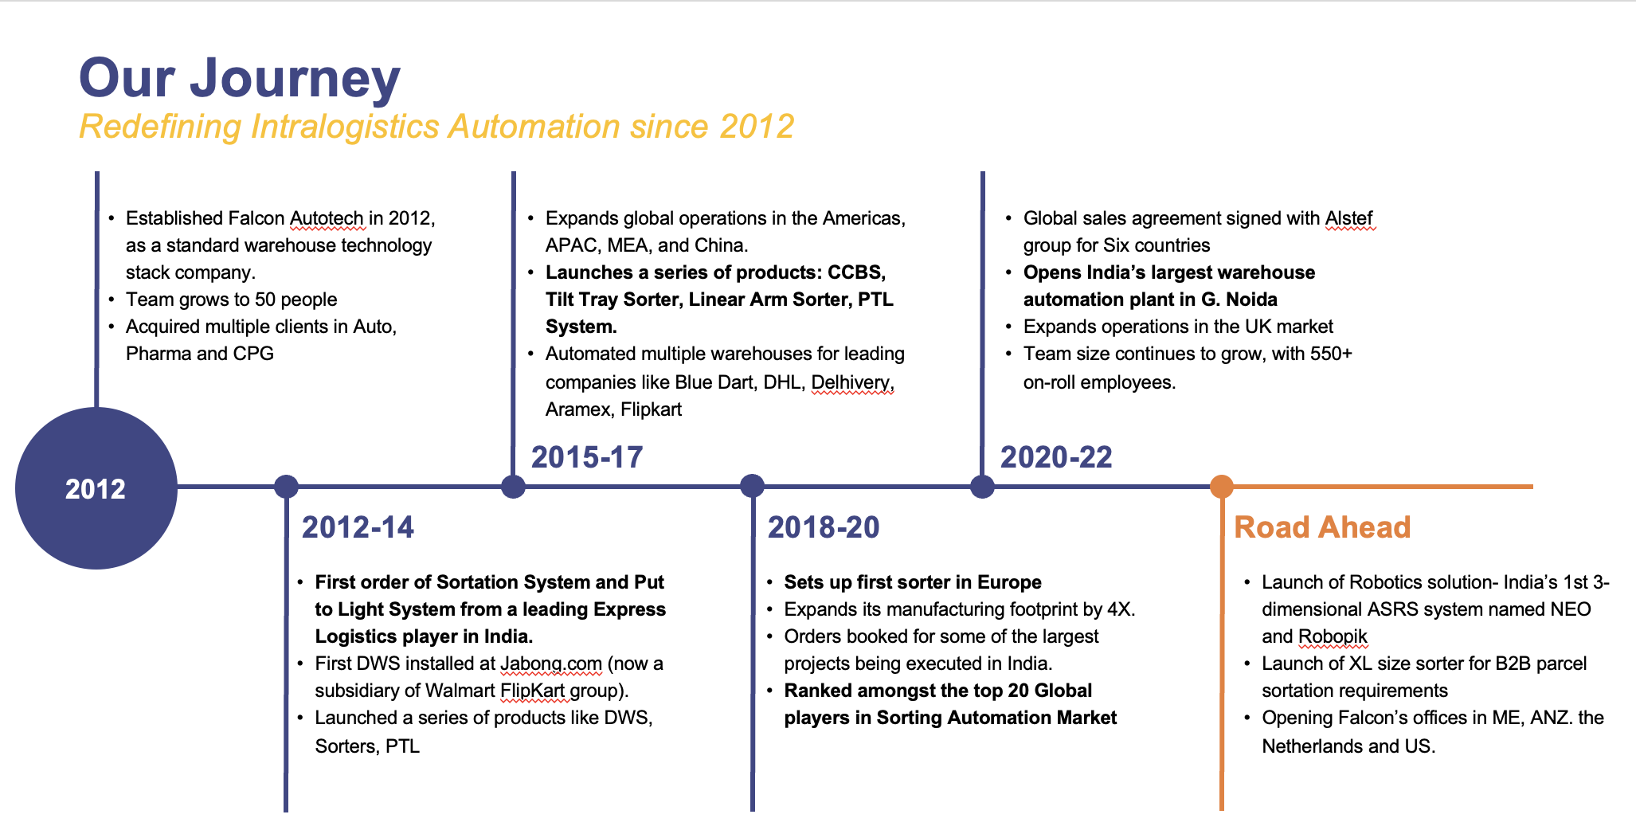
As a leading player in the intra-logistics automation space, Falcon continuously strives to improve the operational efficiencies and accuracies for its clients through its domain knowledge and experience in addition to its wide range of products and solutions. In order to be able to live up to the high expectations set forth by our clients, the team at Falcon realizes the importance of taking up selective applications in focused Industries and deliver world class projects in return.
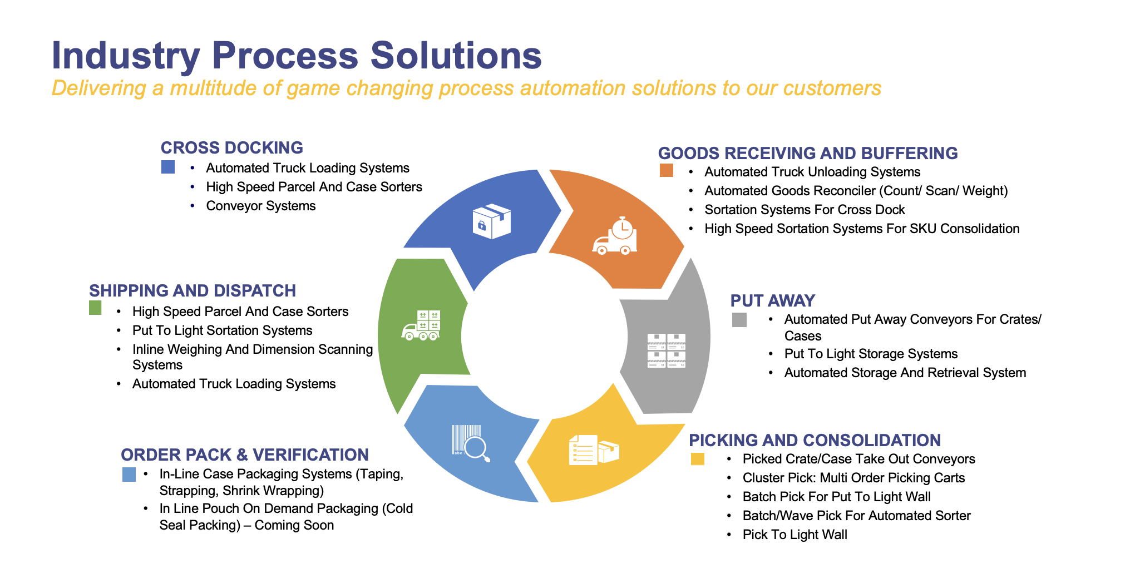

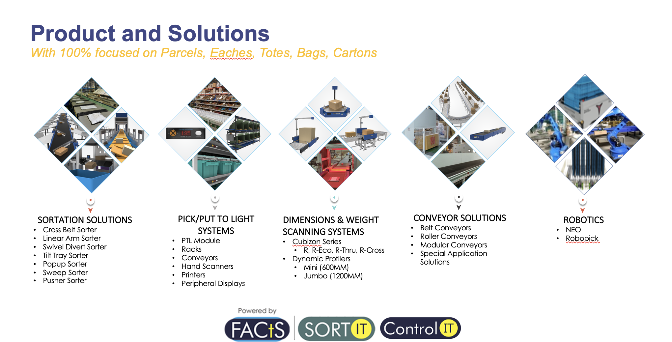
Falcon Autotech has successfully delivered warehouse automation solutions based on smart and innovative combinations of above product lines for effective materials handling, sortation and movement. The process is controlled in real-time by our in house WCS applications. These solutions considerably cut the need for manual operations, improve working conditions and ensure the highest accuracy of the entire process up to final delivery to the recipient.
Over the last 10 years, Falcon has worked with some of the most innovative brands worldwide and has established long standing partnerships. These brands are testimony of our strong focus on delivering superior customer satisfaction and offering end-to-end intralogistics solutions.
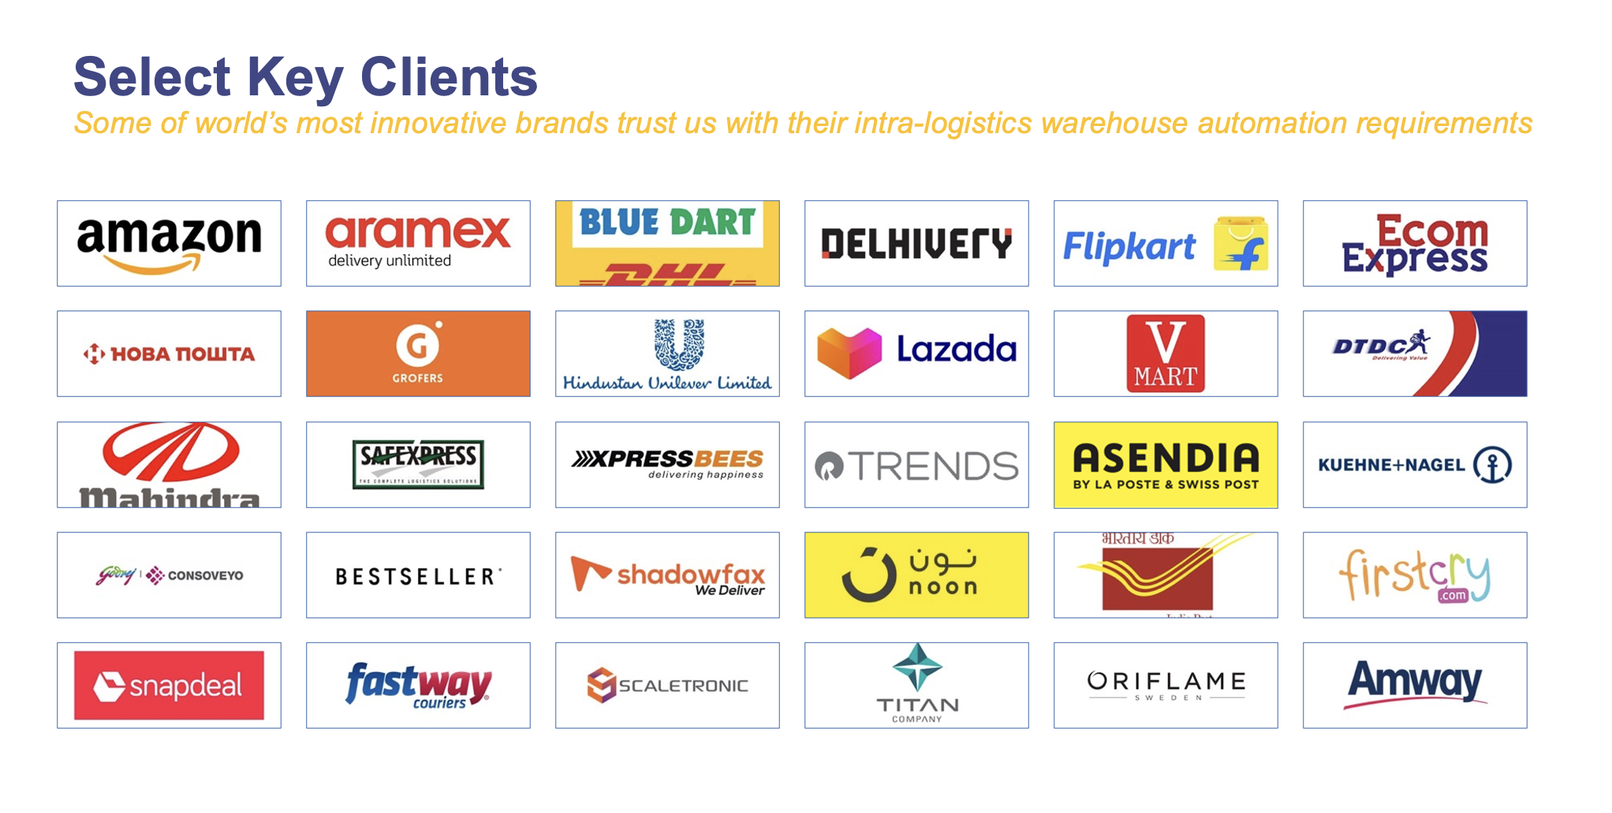
With over 1,800 installations, today Falcon’s systems are used all over the globe. Falcon has highly motivated team of 600+ employees supported by over 15 global partners who help us design, manufacture, deliver and maintain automation solutions globally.
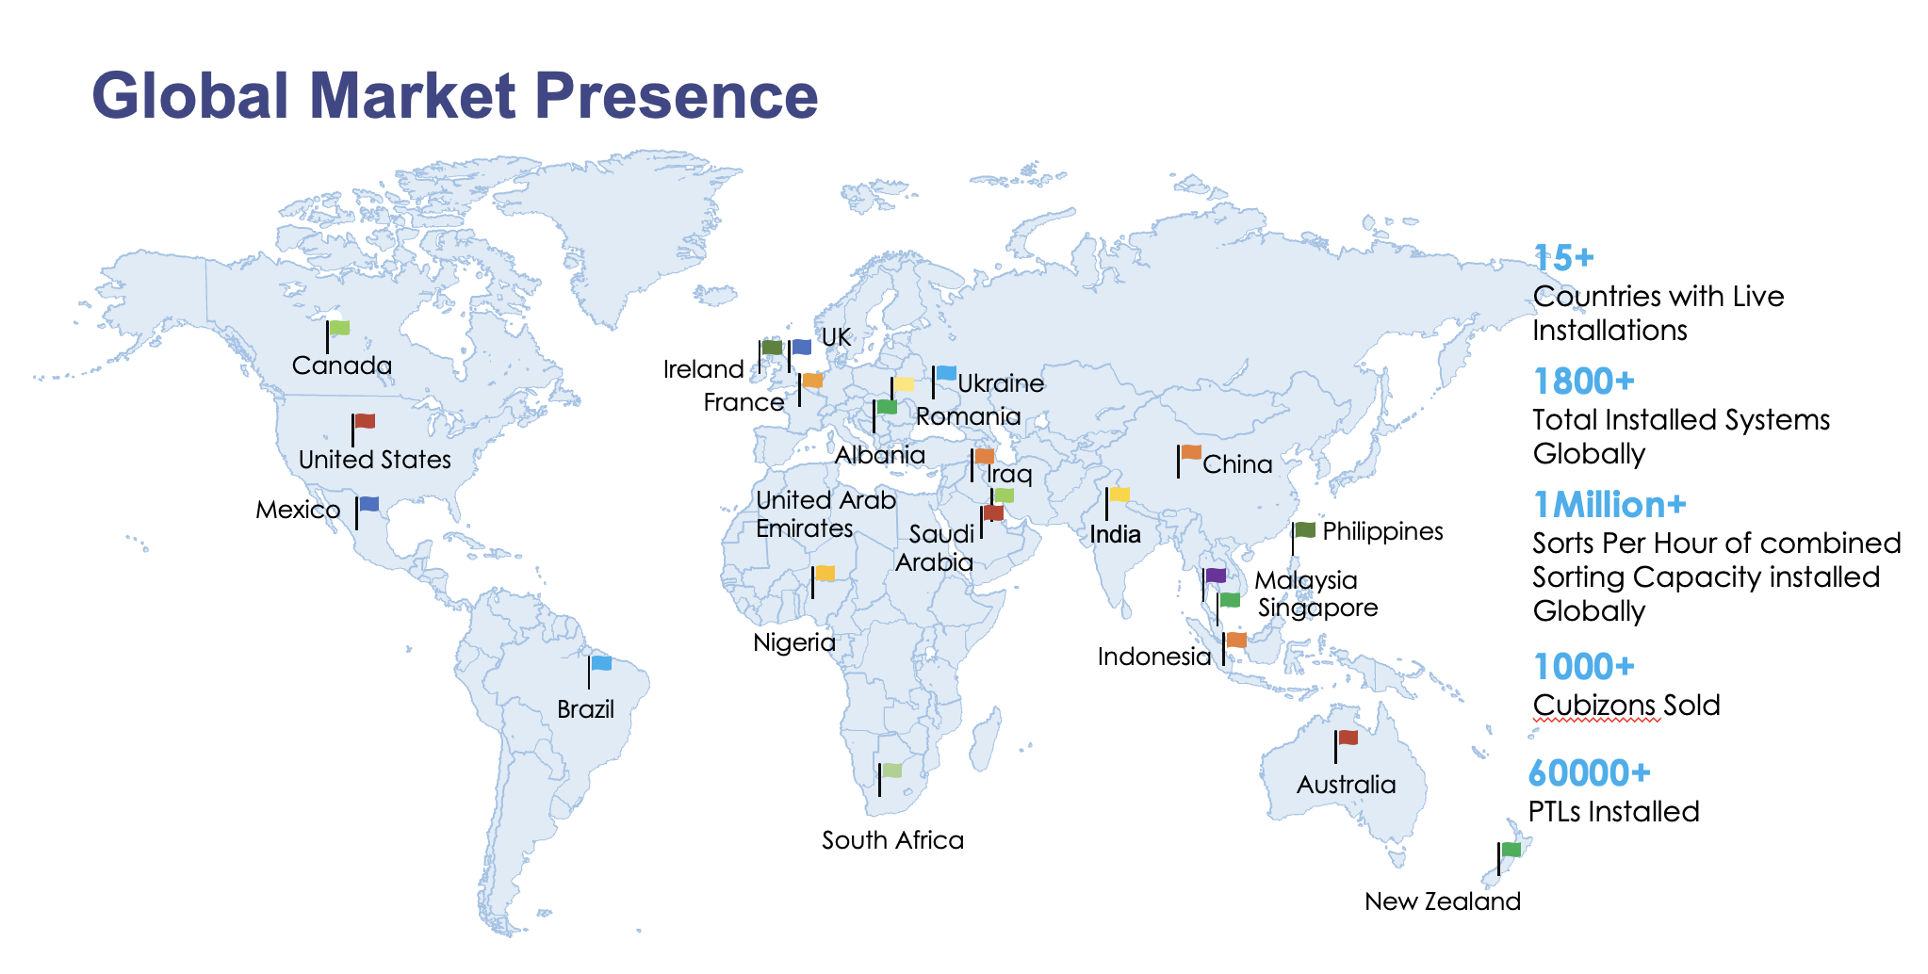

Falcon’s Experience and Achievements in Sortation Space Globally
- Ranked among Top 20 Sortation System Suppliers globally. Only company from APAC/EMEA Region.
- Currently possess one of the World’s largest portfolios in Sortation Technologies: 7 In-house technologies.
- Total installed capacity of 10 million Shipments per day worldwide.
- Only company to be able to offer a Fully Integrated AMS.

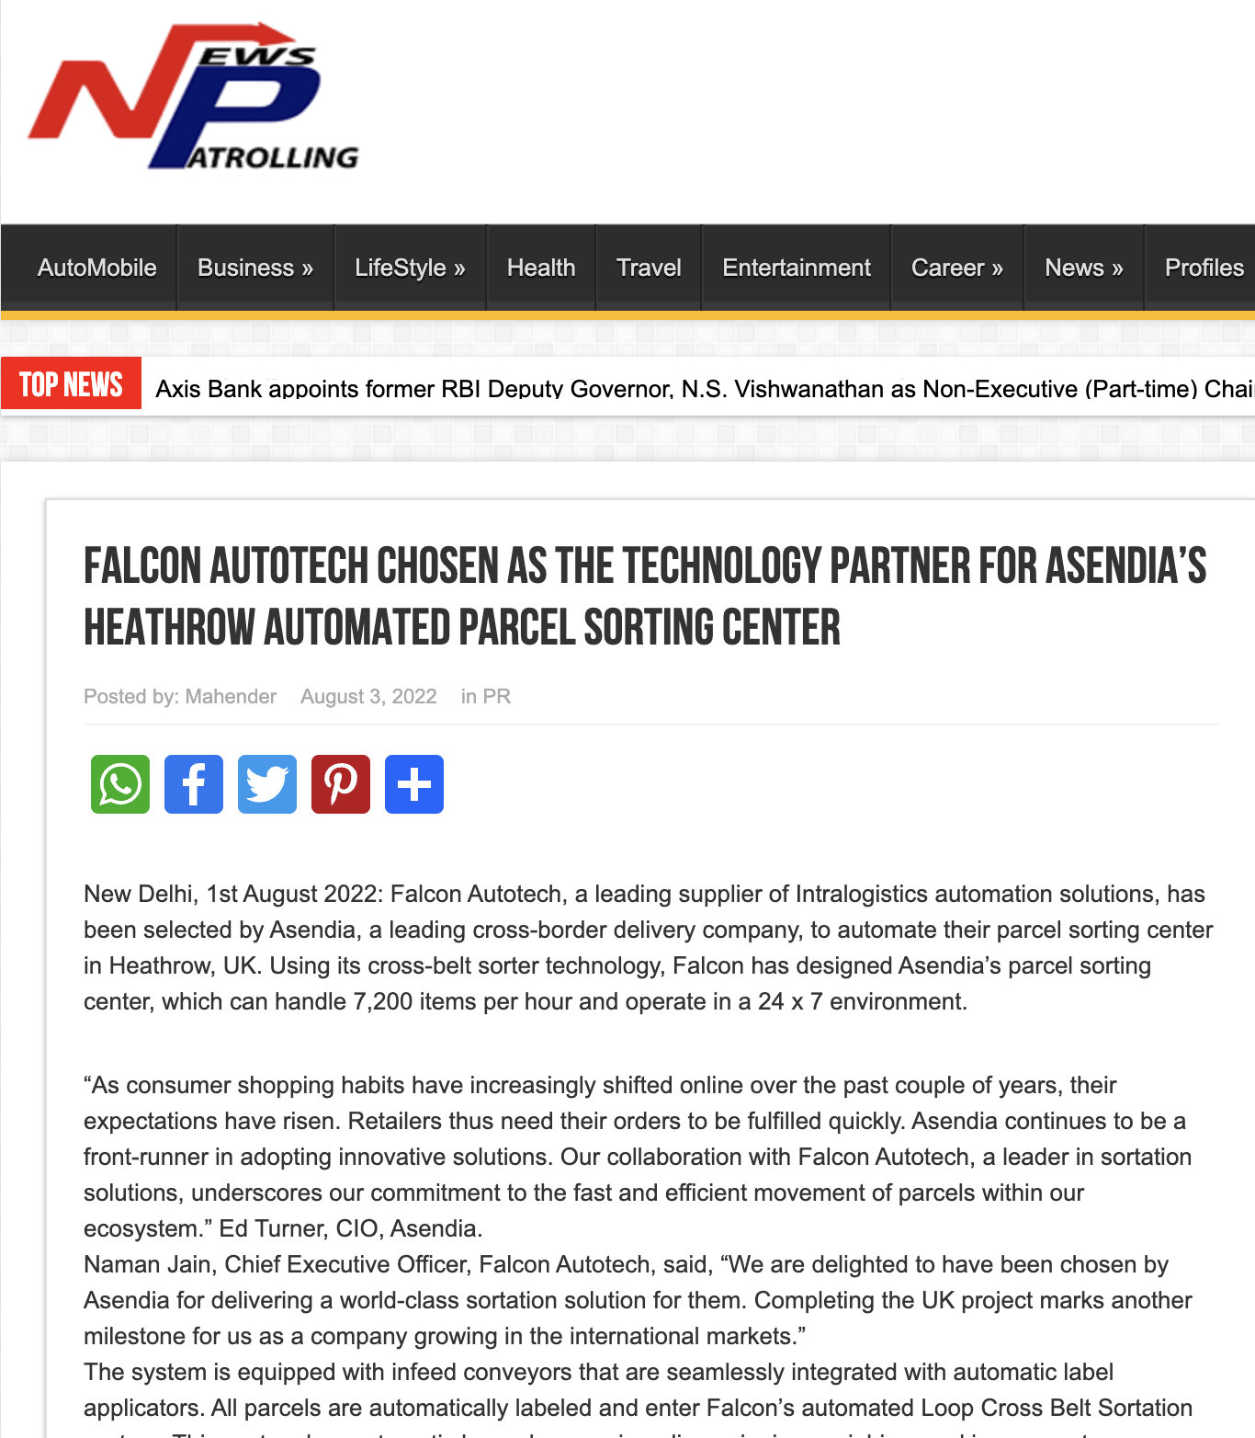




Reference Projects
Falcon has a strong legacy in Warehousing Automation solutions and references-

- Expertise in Shipment Sortation, Piece Picking and Handling, Case Picking and Handling.
- Lifecycle services (maintenance, spares supply chain, support).
- Full in-house expertise (Hardware/Software).
- Turn-key tailored solutions.
The references list presented below focuses on Sortation Solution –

Project 1- (CEP Client, India)
The System is equipped with two fully automated and interconnected Sub-systems. Sub-System 1 is designed for handling large B2B boxes and E-commerce shipment bags while the Sub-System 2 is designed to handle Small E-commerce packages.
Solution Specifications –
  - 48,000 PPH (Double Deck CBS- Shipment Sorter)
  - 17,000 PPH (Double Deck CBS- Bag Sorter)
- Building Size: 700,000 Sq. Ft
Key Technology Modules –

- 2 Sets of Double Decker CBS Sorters
- Mezzanine Structures (one large mezz on to install a double decker Sorter).
- Automated Singulators
- Fully Automatic Inductions
- Semi-Automatic Inductions
- Telescopic belt conveyors
- PVC Belt Conveyors
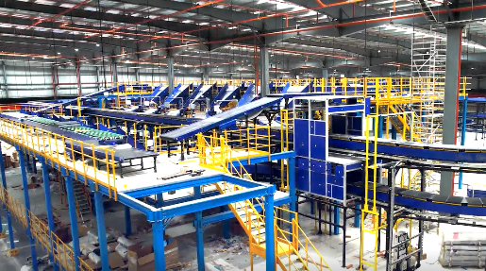
Site Pictures -
- Modular Belt Conveyors
- Spiral Chutes with Braking rollers
- 5-Sided Scanning Tunnels
- High speed weighing conveyors
- Direct Bagging Chutes
- Put to Light Chutes
- Volume Distribution systems
- High Availability Server Systems
- WCS
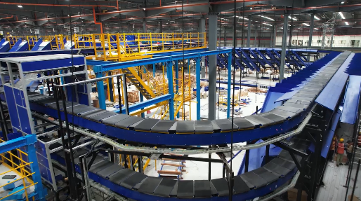
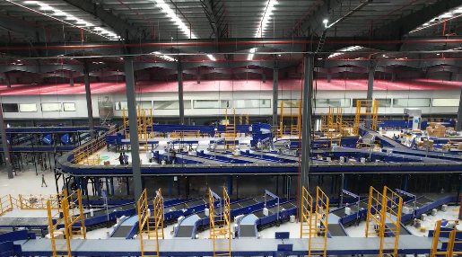
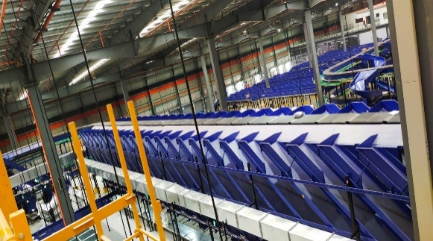
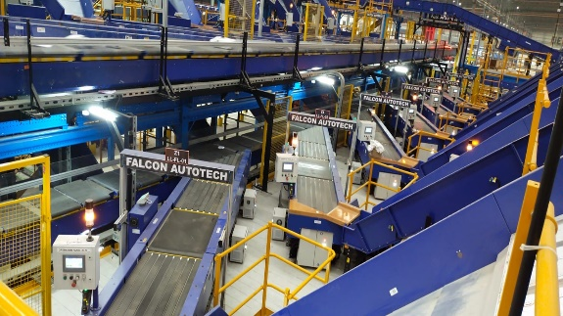

Project 2- (Client – E-Commerce, India)
Use Case – Destination Sorting of Packed Shipments.
In 2019, Client was looking for a potential automation partner for design and development of a new automated sortation system for B2C shipments. The system should be able to provide maximum uptime with reduced dependency on skilled manpower, and space optimization.
The customer chose Falcon Autotech based on its unique design which could cater to all their pain points, capability of seamless integration with WMS and life cycle support services.
Solution Specifications –
- Throughput: 27,600 PPH
- End Destinations: 410 Direct Outputs
- Building Size: 200,000 Sq Ft
Key Technology Modules –
- Bulk Infeed Conveyors.
- ARB based Volume Distribution System
- Integrated Presort System.
- Irregular Ejection System.
- Automatic Induct Lines.
- Automatic Barcode Scanner with Image Capture.
- Automatic Weight & Volume Measurement System.
- Loop Cross Belt Sorter.
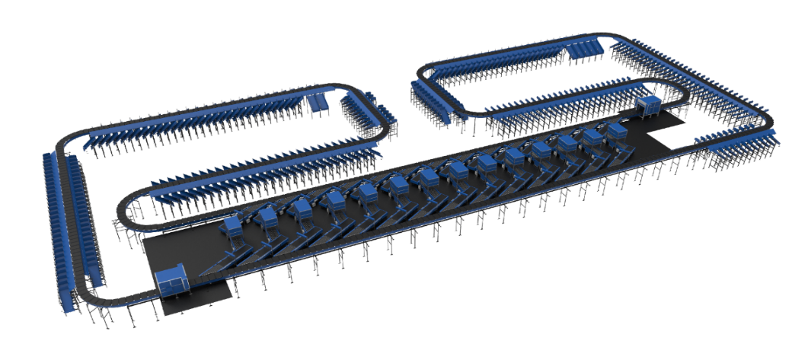
- Smart Sliding Chutes for Direct bagging and Cage Sorting.
- Bag take out system
- WCS Software System.

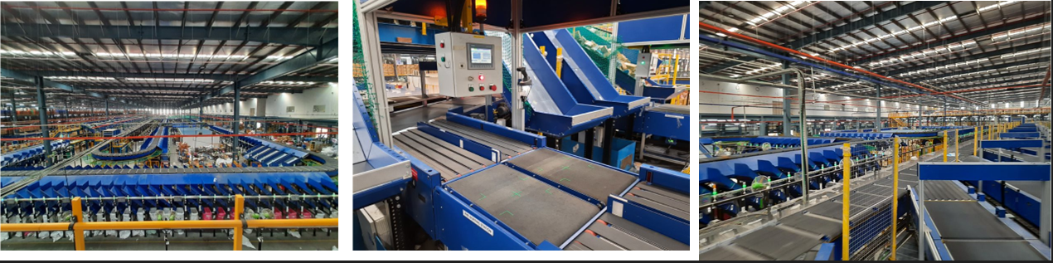

Project 3- (Ecommerce Client, India)
Use Case - Destination Sorting of Packed Shipments
Solution Specifications –
- Throughput: 24,000 PPH
- End Destinations: 110
- Building Size: 200,000 Sq. Ft
Key Technology Modules - Loop Cross Belt Sorter with a cell size of 900 x 500 mm
Layout and Site Pictures -
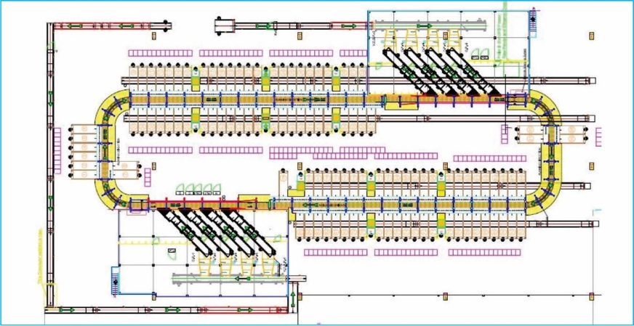

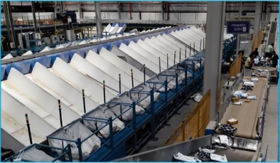
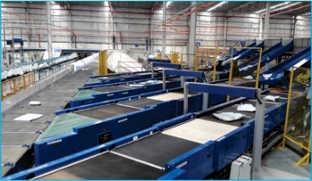

Project 4- (CEP Client, UK)
This Solution is designed to handle a volume of 7200 shipments per hour. The system is equipped with three infeed conveyors integrated with an automatic label applicator before shipments enter the sortation system. The shipments are sorted using Falcon's Loop Cross Belt Sorter equipped with automatic barcode scanning, dimensioning, weighing and image capture capabilities. The sorter is installed on the mezzanine floor and sorts directly to 58 end destinations.
Solution Specifications –
- Throughput: 7200 PPH
- End Destinations: 58 Nos
Key Technology Modules –
- Powered Belt Conveyors.
- Automatic Induct Lines.
- Automatic Barcode Scanner with Image Capture.
- Automatic Weight & Volume Measurement System.
- Loop Cross Belt Sorter.
- WCS Software System.
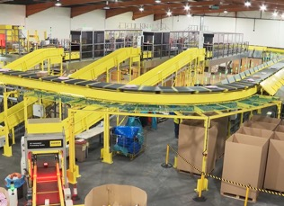
Site Picture –

Project 5- (CEP Client, Sydney)
Solution is designed for handling a throughput of 16,000 shipments per hour with the help of Falcon’s Loop Cross Belt Sorter. The system consists of 2 feeding zones with a total of 10 feedlines. Sorter design enables the van drivers to directly drop the shipments at the dock doors. It has a total of 369 end destinations that are achieved with a combination of direct drops and PTLs. System is integrated with 5 side automatic barcode scanning, weight and volume measurement and automatic detection of oversize and overweight shipments.
Solution Specifications –
- Throughput: 16000 PPH
- End Destinations: 369 Nos
Key Technology Modules –
- Powered Belt Conveyors.
- 2 Induct zone.
- 5 side Automatic Barcode Scanner.
- Automatic Weight & Volume Measurement System.
- Automatic detection of oversize shipment.
- Loop Cross Belt Sorter.
- WCS Software System.
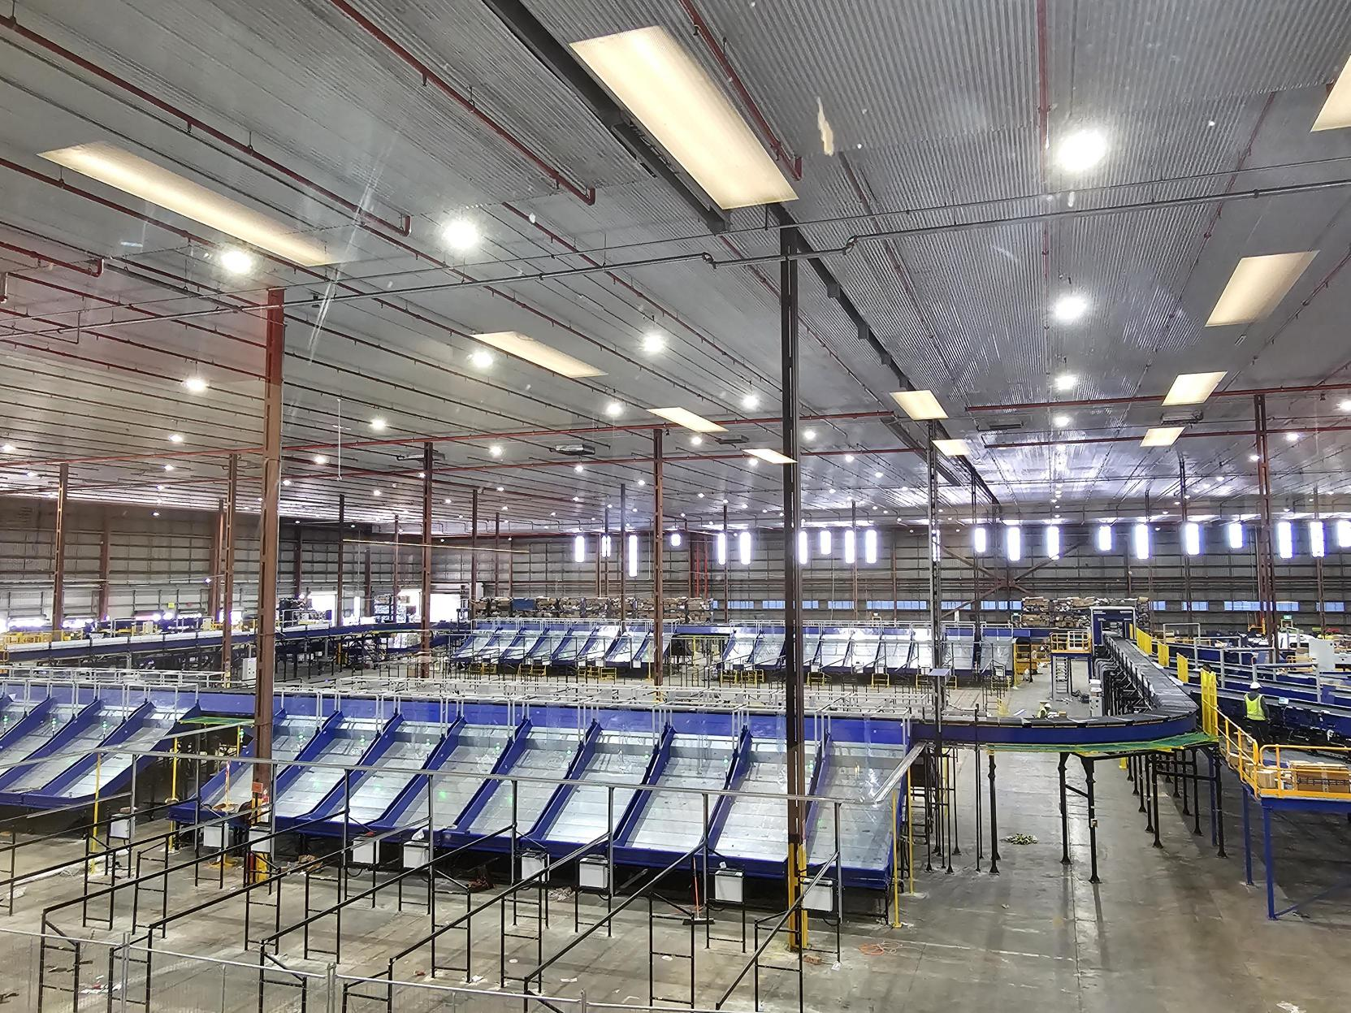
Site Picture –

About Falcon
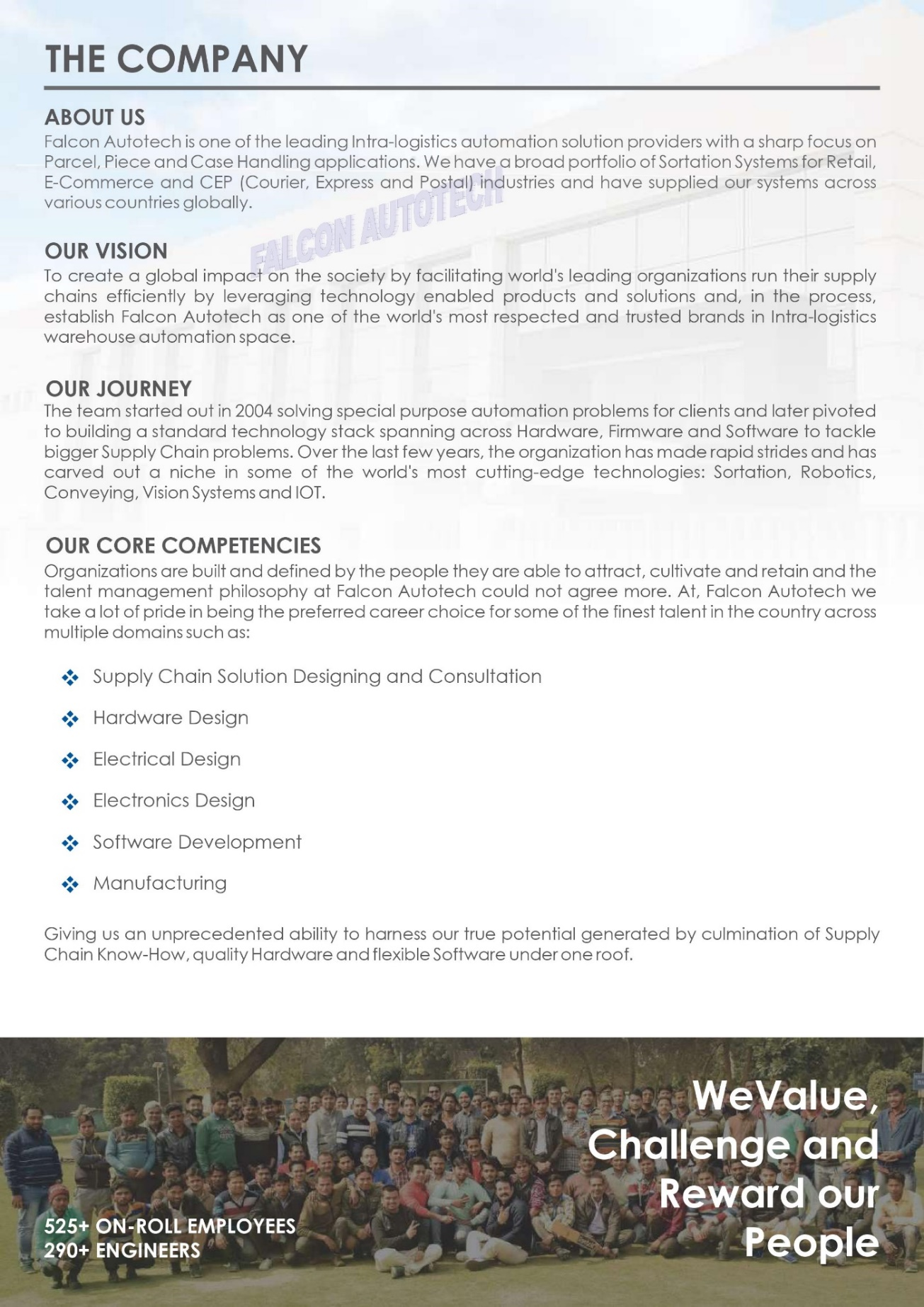
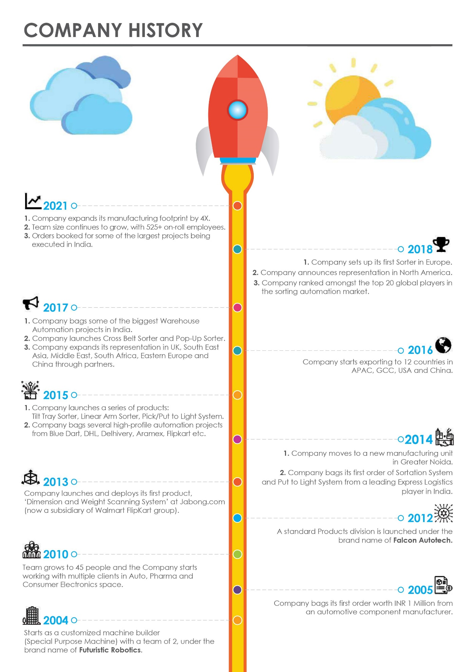
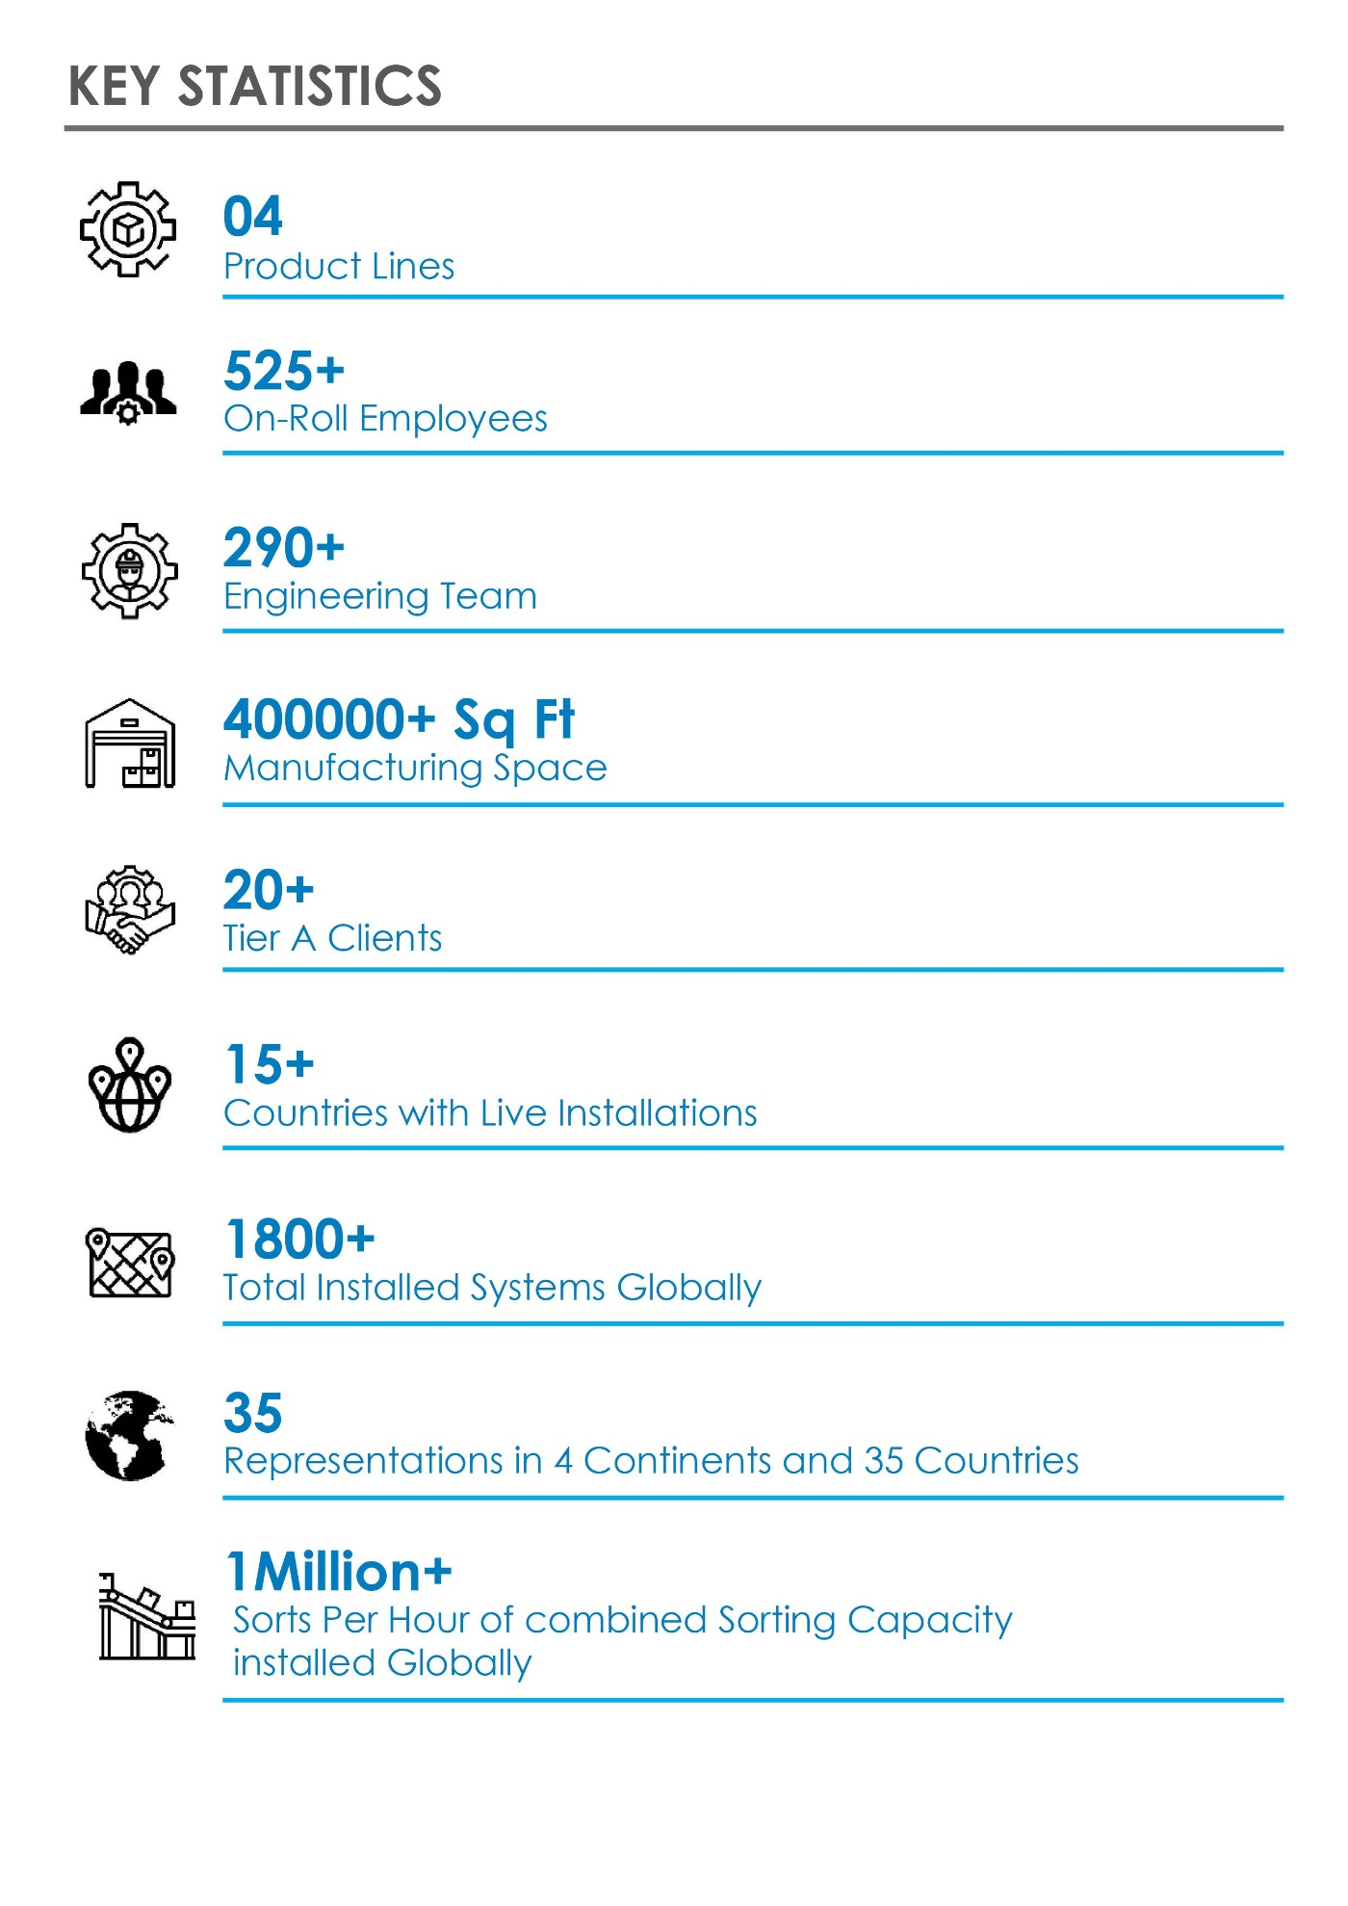
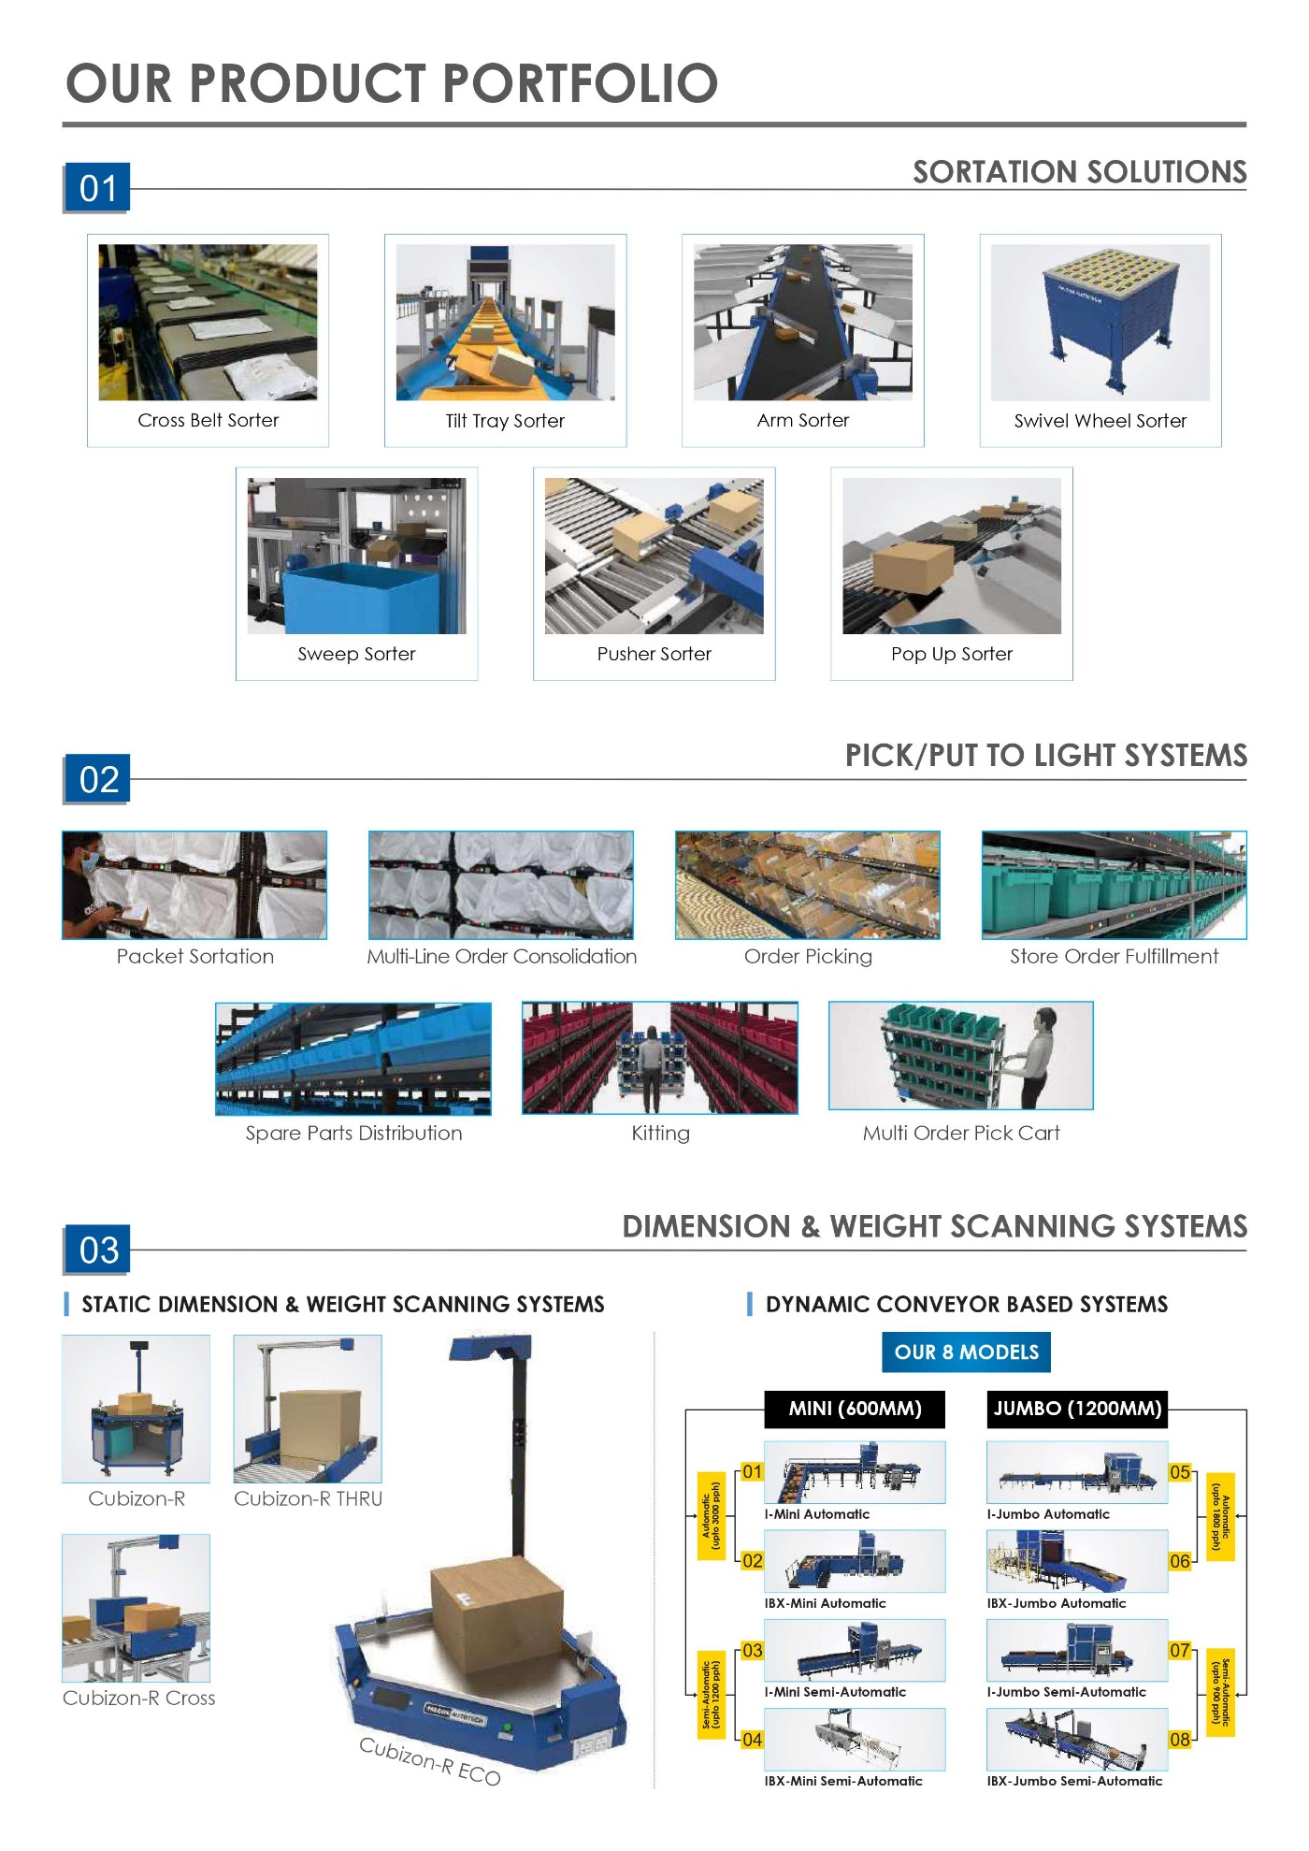
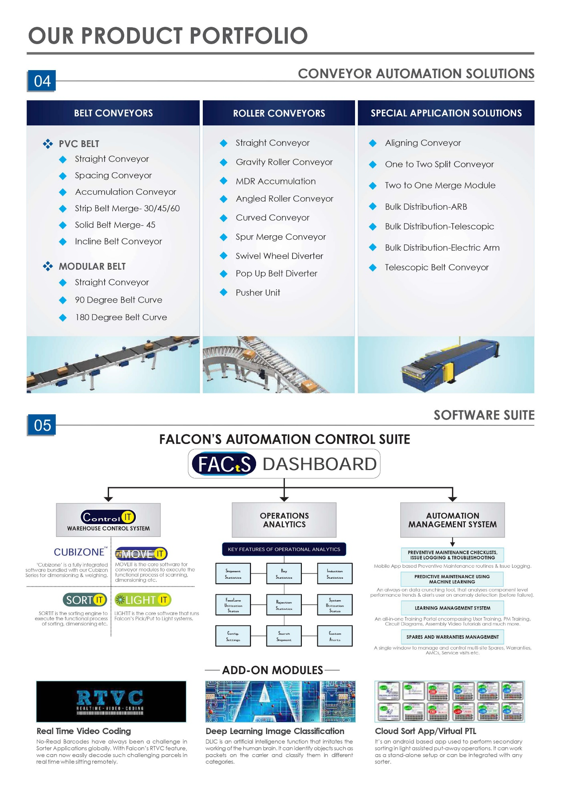
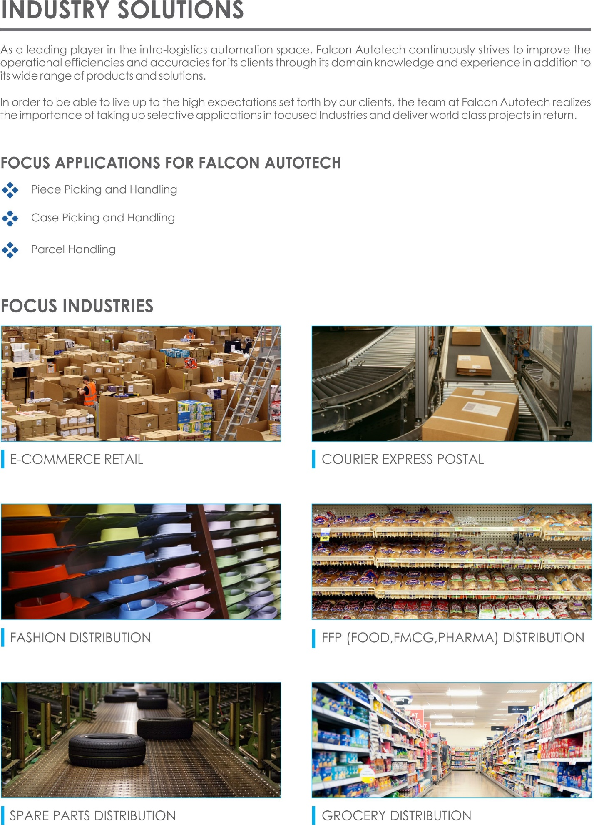
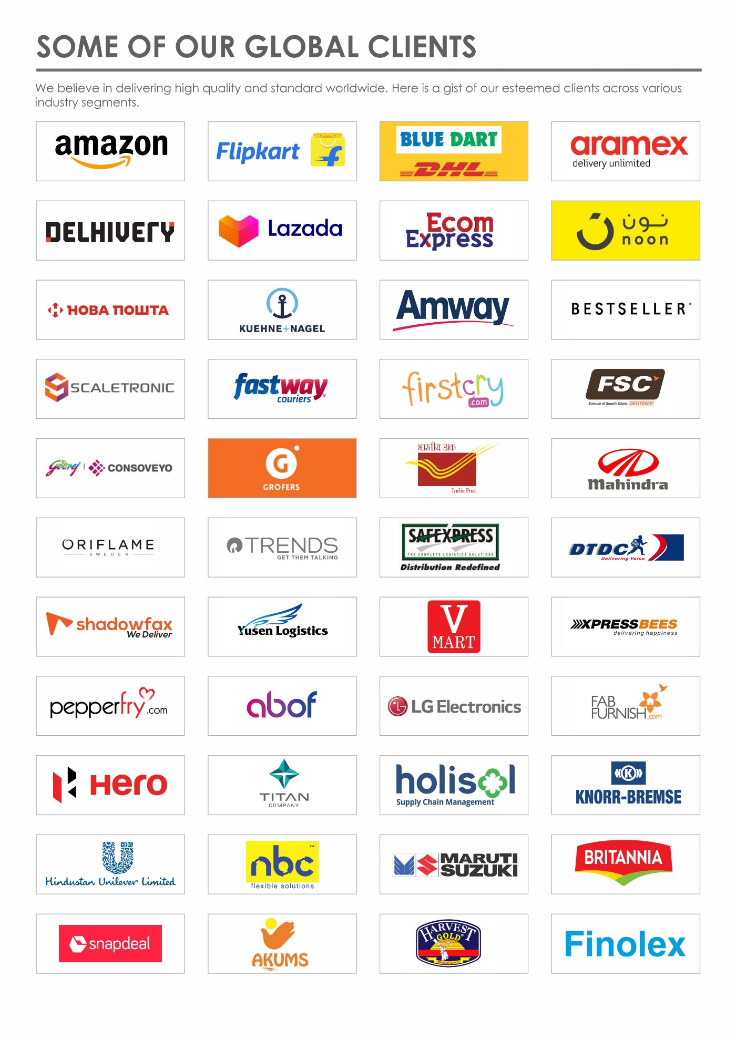

Weight base rejection system
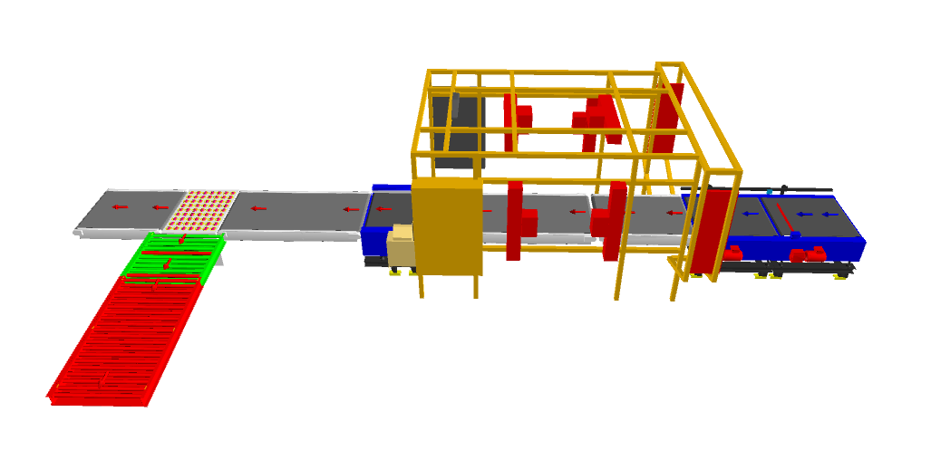

Handled Parcel Spectrumions Minimum Maximum

Parcel size Conveyable on the entire system.

Specification | Unit | Value
Max Length | mm | 800
Max Width | mm | 800
Max Height | mm | 600
Max Weight | Kg | 35
Min length | mm | 150
Min Width | mm | 150
Min Height | mm | 50
Min Weight | Kg | 0.1
Weighing Accuracy | Kg | +- 0.06 or 0.5 %, whichever is higher

Parcels to be loaded on Conveyor/Sorter shall have the following characteristics:

- Centre of Gravity of Item must not move during conveyance or sorting.
- Item must not have magnetic content, otherwise behaviour of parcel cannot be guaranteed.
- Parcels shall be perfectly and safely packed: protrusion or open surfaces are not allowed.
- Plastic ropes shall be perfectly adherent to the surface of the package.
- Items must be robust enough to avoid disintegration of container material and loose of contents in the sorting process.
- Item packaging shall have enough grip to be handled on the belts during the acceleration and referencing phases.
- Items shall not have slippery surfaces and must be able to withstand acceleration of the belt during the start-stop phases (accelerations up to 0.5 g shall be assured without any sliding or tumbling of the items on the belt conveyor).
- The parcels must have at least one flat and regular surface providing enough stability during conveyance.
- All shapes are permitted except spherical, cylindrical, or alike unstable items & shapes.
- All usual packaging materials are permitted (including paper, carton, plastics, plastic foil, rope, tape, textile, and wood)

Parcel not loadable on the system
All products that are within the range as described here, are considered non- conveyable products, and must be taken out of the main sorter flow by the operators.
- Unstable items with a risk to roll on the sorting system, such as spherical or cylindrical items
- Items that are packed in material that can damage the conveyors or the sorter.
- Items that have sharp points (e.g., Nails) or sharp edges, that can damage the conveyors
- Items that have been classified as dangerous.
- Wet items.
- Items with anti-slip treatment.
- Items with protruding parts.
- Inadequately packed items that could be damaged during automatic transportation.
- Electrostatically loaded items.
- Loose parts on Items such as adhesive tape, stickers, slips of paper, straps, wrap foil etc.
- Liquid or fragile material, to avoid breaking, spillage or leakage, such as wine bottles, metal cans of paint.
- All items with the risk of being damaged during the transport on an automatic sorting system or damaging the sorting system.

Types of Parcels
Parcel Type | Description
Corrugated Box/Cartons | Min: L-150 X W-150 X H-50 MM  Max: L-800 X W-800 X H-600 MM
Shipments

Proposed System Description

Objective
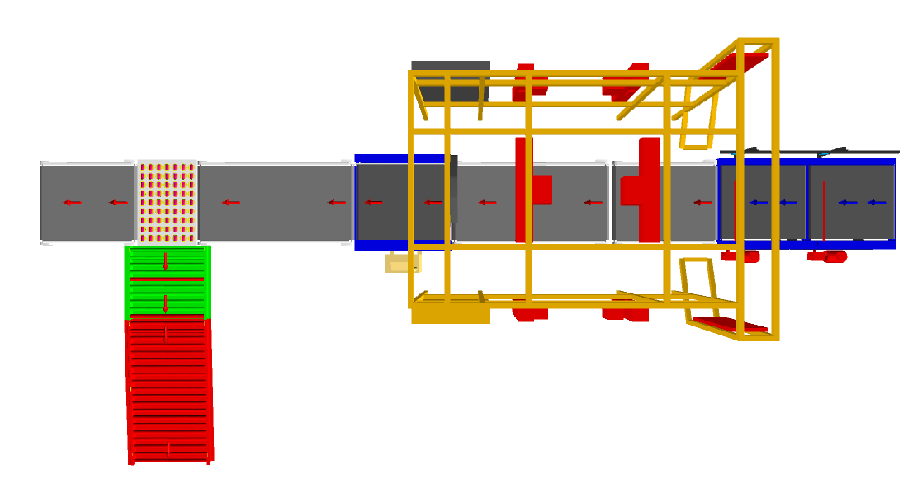
The purpose of this proposal is to present the design, manufacturing, installation, commissioning, testing and acceptance testing of the fully auto Weight base rejection system to handle cartons/boxes as per specifications shared by Flipkart.
SWEDI Diverter
Scanning Tunnel

Roller Conveyor

Weighing Conveyor
PVC Belt Conveyor
Scanning Conveyor
Spacing Conveyor
Idler roller Conveyor

Proposed System Layout

Process Flow
The shipments will be loaded on the existing conveyors placed before the spacing units. The shipment passes through spacing conveyors creating enough space between parcels and enters the automatic barcode scanning tunnel (Six Side barcode scanning) where the barcode data is read, the weight is measured and stored in the system. In case of barcode not being read or overweight the parcel will be rejected by the SWEDI divert onto the rejection roller conveyor. In case of a successful data capture & allowable weight the parcels shall head straight onto the output Conveyor.

Main benefits of the proposed solution
The proposed solution has the following advantages:
- High operational throughput
- Low occupancy of floor space in the building

System Components

Spacer
It is a Dual set of high-speed conveyors, using to create appropriate space between parcels/boxes.
Some Salient Features of Falcon’s spacing conveyor:
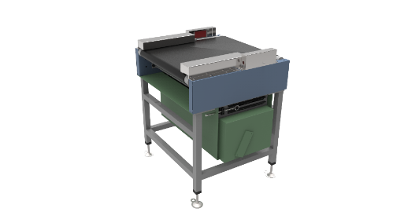
- Low Noise
- Maximum uptime.
- High safety standards.
- Fastest ROI
- Comes with MS frame.

Specification | UOM | Remark
Manufacturer Name | Name | Falcon Autotech
Material of Roller | Type | MS Rollers with Zinc Plating
MOC of Belt | Type | PVC
Belt Thickness | mm | 3
Belt Finish | Type | Matt Finish
Belt width | mm | 1000
Belt Joint Type | Type | Vulcanized, Endless Belts
Belt Make/Model No. | Make | FORBO/DERCO
Type of Motor | Type | AC Geared Motor
Type of Drive System | Type | Direct Shaft Mounted Motor/ Flange Mounted
Type of Drive | Type | Chain drive/Torque Arm type

Auto Barcode Scanning System (Top Side)
System is integrated with automated Camera technology for scanning 1D/2D Barcodes.
Some Salient Features of Falcon’s Scanning System:
- High Speed Scanning
- High Accuracy Rates
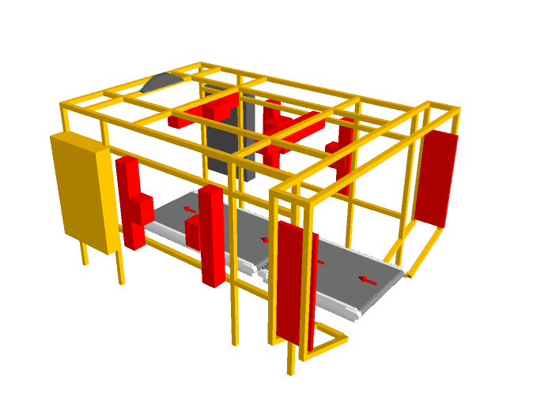
- Effortless Operation
- High safety standards.

*Note : Barcode data of product should be locally available for on time retrieval of weigh data against each barcode.
*Note : In case of six Side scanning, skewness of more than +/- 10 deg may result in no data capture case.

Weighing Conveyor
Falcon’s weighing conveyor is used for inline weighing of parcels.
Some Salient Features of Falcon’s weighing conveyor:
- High Speed Weighing
- Minimal maintenance
- High safety standards.
- High accuracy
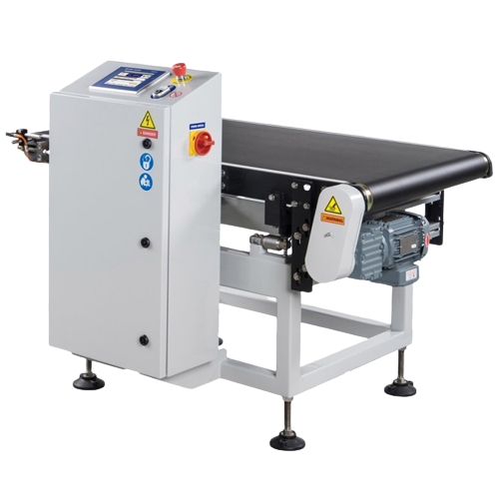
Specification | UOM | Remark
Manufacturer Name | Name | Mettler Toledo/Bizerba
Carton Size | Mm | Min: 150 x 150 x 50  Max: 800 x 800 x 600
Minimum Weight | Kg | 0.1
Maximum Weight | Kg | 35
Weighing Accuracy | Kg | +- 0.06 or 0.5% of product weight, whichever is higher
Weighing Resolution | Kg | 0.001

Swivel Wheel Sorting Unit – Falcon
Falcon’s Swivel wheel divert is used in system for the smooth transfer of products.
Some Salient Features of Falcon’s Swivel Wheel Divert:
- Low Noise
- Maximum uptime.
- Electric based rotation of wheels.
- Minimal maintenance
- High safety standards.
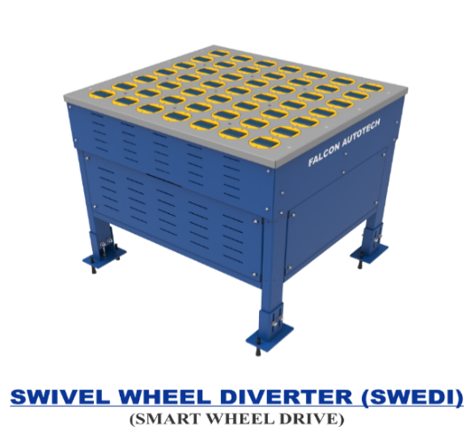

Specification | UOM | Remark
Manufacturer Name | Name | Falcon Autotech
Type - Equipment | Type | Merge/Sorting
Type - Operation | Type | Sorting
Mechanism for Swivel | Type | Electric servo motor
Roller drive | kW | Powered smart wheel
Roller pitch (L x W) | Type | 110 x 120
No. of divert sections | Yes/No | 1 or 2
Max. product weight (kg/m2) | kg/m2 | 25
Throughput | PPH | 2500
Type of Mounts | Type | Fixed Heights Legs with Grouting Provisions

PVC Belt Conveyor
Falcon’s Belt Conveyors are modular & robust in design. MS profile is used to build conveyor frame.
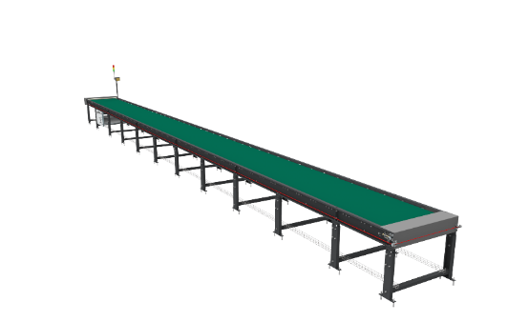
Some Salient Features of Falcon’s Belt conveyor:
- Low Noise
- Maximum uptime.
- Minimal maintenance
- High safety standards.
- Fastest ROI.

Specification | UOM | Remark
Manufacturer Name | Name | Falcon Autotech
Material of Roller | Type | MS Rollers with Zinc Plating
MOC of Belt | Type | PVC
Belt Thickness | mm | 3
Belt Finish | Type | Matt Finish
Belt width | mm | 1000
Belt Joint Type | Type | Vulcanized, Endless Belts
Belt Make/Model No. | Make | FORBO/DERCO
Chassis | mm | MS, 3mm Thick, Powder Coated-75 Microns
Idler Roller Pitch on running side (Top) | mm | 480
Idler Roller Pitch on return side (Bottom) | mm | 1200
Idler Roller Specs | Spec | Dia.50.8, shaft-12 mm, bearing-6301
End Rollers | Spec | Dia 81.2 x 2.85 Thick, 30mm Shaft Dia, & Bearing Size-UCFH206D1, MOC-EN9, Zinc Plated -25 microns
Drive Rollers | Spec | OUTER Dia 178 PIPE Dia 168x5 Thick, 40mm Shaft Dia, & Bearing Size-UCF208D1, MOC(SHAFT)-EN9, NEOPRENE RUBBER COATING
Tensioning Rollers | Spec | Dia 81.2 x 2.85 Thick, 25mm Shaft Dia, & Bearing Size-UCT205D1, MOC-MS, Zinc Plated -25 microns

Powered Roller Conveyor
Falcon’s Roller conveyors are highly energy efficient and require negligible maintenance leading to very minimal Operating costs and thus lower cost of ownership.
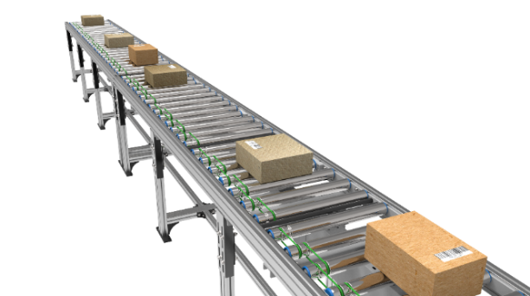
Some Salient Features of Falcon’s roller conveyor:
- Low Noise
- Maximum uptime.
- Minimal maintenance
- High safety standards.
- Fastest ROI
- Comes with MS frame.

Specification | UOM | Remark
Manufacturer Name | Name | Falcon Autotech
Material of Roller | Type | MS Rollers with Zinc Plating
Overall Width | mm | 1000
Conveyor Height | mm | Variable as per design shared
Drive Power Rating | Watt | 40
Type of Motor | Type | DC Rollers (MDR)
Ingress Protection | Type | IP 54
Type of Drive System | Type | Poly V Belt Drive
Insulation Class | Type | Yes
Conveyor Speed | m/s | Variable speed to meet TPH requirements
Load capacity/unit length of Conveyor | kg/m | 50
Roller Span | mm | Variable
Roller Diameter | mm | 50
Pitch of Rollers | mm | 75/100
Type of Mounts | Type | Fixed Heights Legs with required Grouting Provisions

Idler Roller Conveyor
Falcon’s Roller conveyors require negligible maintenance leading to very minimal Operating costs and thus lower cost of ownership.
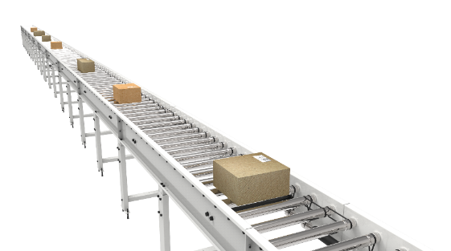
Some Salient Features of Falcon’s idler roller conveyor:
- Low Noise
- Maximum uptime.
- Minimal maintenance
- Comes with MS frame.

Specification | UOM | Remark
Manufacturer Name | Name | Falcon Autotech
Material of Roller | Type | MS Rollers with Zinc Plating
Overall Width | mm | 1000
Conveyor Height | mm | As per Layout requirement
Load capacity per unit length of Conveyor | kg/m | 50
Roller Span | mm | approx. 600
Roller Diameter | mm | approx. 50
Pitch of Rollers | mm | 75
Type of Mounts | Type | Fixed Heights Legs with Grouting Provisions
Type of Guides | Type | Yes
End Stopper | yes/no | Yes

Proposed System Technical Details/BOM

Mechanical equipment
S.No. | Qty. | Description | Value
1 | 1 | Weight base rejection system  Spacing Conveyor  Barcode Scanning Conveyor  Weighing Conveyor  Automatic Barcode Scanner (Six Side)  PVC Belt conveyor  SWEDI Divert unit  Powered Roller conveyor  Gravity Roller conveyor | 2 Set  2 Set  1 Set  1 Set  2 Modules (Length-3.2 m)  1 Set  1 Module (Length-1 m)  1 Module (Length-2 m)

Electrical Equipment
Electricals
FC1 | 1 | Electrical Cabling and Wiring  Main Power Distribution panel  Main Control Panel  Network Switches  Field Cabling | Included

Control System
Components
FC2 | 1 | Controls and IT Infrastructure Controls  Weigh Scale Control, Barcode Scanner Controls,  Control IT Software Package | Included

Program Organisation

Delivery Schedule
Dispatch within 14-15 weeks from the date of signed PO, advance and DAP whichever is later.

Commercial Terms

Price Sheet
S. No | Component | Set | Price (INR)
1 | SWEDI Diverter | 1 | ₹ 10,07,232
2 | Scanning & Weighing System | 1 | ₹ 95,57,082
3 | Conveyor Automation | 1 | ₹ 23,23,650
4 | Controls | 1 | ₹ 8,00,000
5 | Toolkit | 1 | ₹ 36,000
6 | Software Packages | 1 | ₹ 6,00,000
7 | Installation & Commissioning | 1 | ₹ 6,86,198
8 | Packaging & Forwarding | 1 | ₹ 2,74,479
9 | Project Management and Engineering Charges | 1 | ₹ 3,82,116
Grand Total (INR) |  |  | ₹ 1,56,66,758
The Total Price is to be understood.
- Ex Works – Greater Noida, India
- Freight charges shall be extra at actual
- Taxes, Customs, Duties extra at actuals
- Including Packing and Forwarding
- Installation and Commissioning: Mentioned above.
- Price is valid for 60 days from the date of proposal
Our Price does not include taxes, and duties, import duties, charges, fees, taxes etc. charged by authorities outside India for deliveries and services. Same shall be borne & paid by client itself.
*Material Unloading & Laydown area is in customer scope

Payment Terms
The Supplier Quotation is based on the following payment schedule:
Stage 1: 50% Advance along with PO.
Stage 2: 30% along with 100% Taxes prior to dispatch.
Stage 3: 20% Within 30 days of Commissioning.

Warranty Period
Falcons offered System comes with a standard warranty of 1 year and post completion of warranty, customer can opt for Extended warranty. Warranty covers the following support:
- 24 X 7 Telephonic, Email and Remote Service Support when required
- Regular Software updates and Bug Fixes.
- Supply of Mechanical and Electrical components in case of failure (excluding damages as mentioned in Exclusion Clause)
The warranty does not apply to replacement or repair of:
- Faulty articles:
  - Failure to comply with the manufacturer's recommendations (logistics documentation, Technical Information Note, retrofit document) and the rules of the trade.
  - Negligence or abnormal use of equipment.
  - Anomalies produced by an environment of use, storage or transport that does not comply with the specifications or recommendations of Falcon: packaging, temperature, hygrometry, sector, insulation, etc.
  - A defect due to a cause external to the supplies and services of Falcon.
- Equipment other than that supplied by Falcon.
- Items that can be repaired exclusively by Falcon that have been repaired or attempted repairs other than those carried out by Falcon.
- Items that fail due to normal wear and tear of one or more of its components or whose tamper-evident seals (varnish, strip, etc.) have been broken or whose serial numbers have been removed or modified.
- Items damaged during transport to Falcon due to the use of unsuitable packaging.

Exclusions
The scope of supply includes all parts which are defined in the Supplier’s quotation.

All other parts which are not defined in the Supplier’s quotation do not belong to the Supplier’s scope of supply and are excluded. The following parts are also excluded:

- Low Spec Server PC
- Building infrastructure; building structure, doors, fire exits, levelling devices, building extinguisher and fire alarm system, building heating and lighting system.
- Server PC is not included in this proposal
- Electrical power supply and wiring to the main control cabinets
- UPS for Controls and Drives
- Electrical Power for Installation
- Network Cabling up to the Main Server Rack
- Intermediate wiring to parts which are to be supplied by the Purchaser/others
- Emergency/Uninterruptable power supply
- Fire-alarm and fire protection devices
- Traffic and route markings
- Laydown Area
- Ram protection devices
- Cat walks, bridges, maintenance aisles and platforms
- Assembly tools like forklifts and hoisting machines
- All kind of network incl. Local Area Network (LAN/WLAN), exceeding the scope described in Scope of Supply
- Any Kind of Civil work
- Any adjustment of the Supplier’s scope of supply to local rules and regulations
- X-Ray machines
- Roller cages/ Pallets
- Simulation and 3D animation of the sorter system
- Interface with other equipment not specified in this offer.
- Provision of facilities for the control room (furniture, air conditioning, heating, etc.).
- The supply and installation of fencing around the different corridors.
- Any item specifically indicated as not forming part of the subject matter of the Seller's supply in the offer documentation.

